tidy_data codebook

Autogenerated data summary from dataMaid

2019-07-26 09:58:58

# Data report overview

The dataset examined has the following dimensions:

|  |  |
| --- | --- |
| Feature | Result |
| Number of observations | 180 |
| Number of variables | 81 |

# Codebook summary table

|  |  |  |  |  |  |
| --- | --- | --- | --- | --- | --- |
| Label | Variable | Class | # unique values | Missing | Description |
|  | **subject** | integer | 30 | 0.00 % |  |
|  | **activity** | factor | 6 | 0.00 % |  |
|  | **Time BodyAcc mean x axis** | numeric | 180 | 0.00 % |  |
|  | **Time BodyAcc mean y axis** | numeric | 180 | 0.00 % |  |
|  | **Time BodyAcc mean z axis** | numeric | 180 | 0.00 % |  |
|  | **Time BodyAcc std x axis** | numeric | 180 | 0.00 % |  |
|  | **Time BodyAcc std y axis** | numeric | 180 | 0.00 % |  |
|  | **Time BodyAcc std z axis** | numeric | 180 | 0.00 % |  |
|  | **Time GravityAcc mean x axis** | numeric | 180 | 0.00 % |  |
|  | **Time GravityAcc mean y axis** | numeric | 180 | 0.00 % |  |
|  | **Time GravityAcc mean z axis** | numeric | 180 | 0.00 % |  |
|  | **Time GravityAcc std x axis** | numeric | 180 | 0.00 % |  |
|  | **Time GravityAcc std y axis** | numeric | 180 | 0.00 % |  |
|  | **Time GravityAcc std z axis** | numeric | 180 | 0.00 % |  |
|  | **Time BodyAccJerk mean x axis** | numeric | 180 | 0.00 % |  |
|  | **Time BodyAccJerk mean y axis** | numeric | 180 | 0.00 % |  |
|  | **Time BodyAccJerk mean z axis** | numeric | 180 | 0.00 % |  |
|  | **Time BodyAccJerk std x axis** | numeric | 180 | 0.00 % |  |
|  | **Time BodyAccJerk std y axis** | numeric | 180 | 0.00 % |  |
|  | **Time BodyAccJerk std z axis** | numeric | 180 | 0.00 % |  |
|  | **Time BodyGyro mean x axis** | numeric | 180 | 0.00 % |  |
|  | **Time BodyGyro mean y axis** | numeric | 180 | 0.00 % |  |
|  | **Time BodyGyro mean z axis** | numeric | 180 | 0.00 % |  |
|  | **Time BodyGyro std x axis** | numeric | 180 | 0.00 % |  |
|  | **Time BodyGyro std y axis** | numeric | 180 | 0.00 % |  |
|  | **Time BodyGyro std z axis** | numeric | 180 | 0.00 % |  |
|  | **Time BodyGyroJerk mean x axis** | numeric | 180 | 0.00 % |  |
|  | **Time BodyGyroJerk mean y axis** | numeric | 180 | 0.00 % |  |
|  | **Time BodyGyroJerk mean z axis** | numeric | 180 | 0.00 % |  |
|  | **Time BodyGyroJerk std x axis** | numeric | 180 | 0.00 % |  |
|  | **Time BodyGyroJerk std y axis** | numeric | 180 | 0.00 % |  |
|  | **Time BodyGyroJerk std z axis** | numeric | 180 | 0.00 % |  |
|  | **Time BodyAccMag mean** | numeric | 180 | 0.00 % |  |
|  | **Time BodyAccMag std** | numeric | 180 | 0.00 % |  |
|  | **Time GravityAccMag mean** | numeric | 180 | 0.00 % |  |
|  | **Time GravityAccMag std** | numeric | 180 | 0.00 % |  |
|  | **Time BodyAccJerkMag mean** | numeric | 180 | 0.00 % |  |
|  | **Time BodyAccJerkMag std** | numeric | 180 | 0.00 % |  |
|  | **Time BodyGyroMag mean** | numeric | 180 | 0.00 % |  |
|  | **Time BodyGyroMag std** | numeric | 180 | 0.00 % |  |
|  | **Time BodyGyroJerkMag mean** | numeric | 180 | 0.00 % |  |
|  | **Time BodyGyroJerkMag std** | numeric | 180 | 0.00 % |  |
|  | **Frequency BodyAcc mean x axis** | numeric | 180 | 0.00 % |  |
|  | **Frequency BodyAcc mean y axis** | numeric | 180 | 0.00 % |  |
|  | **Frequency BodyAcc mean z axis** | numeric | 180 | 0.00 % |  |
|  | **Frequency BodyAcc std x axis** | numeric | 180 | 0.00 % |  |
|  | **Frequency BodyAcc std y axis** | numeric | 180 | 0.00 % |  |
|  | **Frequency BodyAcc std z axis** | numeric | 180 | 0.00 % |  |
|  | **Frequency BodyAcc meanFreq x axis** | numeric | 180 | 0.00 % |  |
|  | **Frequency BodyAcc meanFreq y axis** | numeric | 180 | 0.00 % |  |
|  | **Frequency BodyAcc meanFreq z axis** | numeric | 180 | 0.00 % |  |
|  | **Frequency BodyAccJerk mean x axis** | numeric | 180 | 0.00 % |  |
|  | **Frequency BodyAccJerk mean y axis** | numeric | 180 | 0.00 % |  |
|  | **Frequency BodyAccJerk mean z axis** | numeric | 180 | 0.00 % |  |
|  | **Frequency BodyAccJerk std x axis** | numeric | 180 | 0.00 % |  |
|  | **Frequency BodyAccJerk std y axis** | numeric | 180 | 0.00 % |  |
|  | **Frequency BodyAccJerk std z axis** | numeric | 180 | 0.00 % |  |
|  | **Frequency BodyAccJerk meanFreq x axis** | numeric | 180 | 0.00 % |  |
|  | **Frequency BodyAccJerk meanFreq y axis** | numeric | 180 | 0.00 % |  |
|  | **Frequency BodyAccJerk meanFreq z axis** | numeric | 180 | 0.00 % |  |
|  | **Frequency BodyGyro mean x axis** | numeric | 180 | 0.00 % |  |
|  | **Frequency BodyGyro mean y axis** | numeric | 180 | 0.00 % |  |
|  | **Frequency BodyGyro mean z axis** | numeric | 180 | 0.00 % |  |
|  | **Frequency BodyGyro std x axis** | numeric | 180 | 0.00 % |  |
|  | **Frequency BodyGyro std y axis** | numeric | 180 | 0.00 % |  |
|  | **Frequency BodyGyro std z axis** | numeric | 180 | 0.00 % |  |
|  | **Frequency BodyGyro meanFreq x axis** | numeric | 180 | 0.00 % |  |
|  | **Frequency BodyGyro meanFreq y axis** | numeric | 180 | 0.00 % |  |
|  | **Frequency BodyGyro meanFreq z axis** | numeric | 180 | 0.00 % |  |
|  | **Frequency BodyAccMag mean** | numeric | 180 | 0.00 % |  |
|  | **Frequency BodyAccMag std** | numeric | 180 | 0.00 % |  |
|  | **Frequency BodyAccMag meanFreq** | numeric | 180 | 0.00 % |  |
|  | **Frequency BodyBodyAccJerkMag mean** | numeric | 180 | 0.00 % |  |
|  | **Frequency BodyBodyAccJerkMag std** | numeric | 180 | 0.00 % |  |
|  | **Frequency BodyBodyAccJerkMag meanFreq** | numeric | 180 | 0.00 % |  |
|  | **Frequency BodyBodyGyroMag mean** | numeric | 180 | 0.00 % |  |
|  | **Frequency BodyBodyGyroMag std** | numeric | 180 | 0.00 % |  |
|  | **Frequency BodyBodyGyroMag meanFreq** | numeric | 180 | 0.00 % |  |
|  | **Frequency BodyBodyGyroJerkMag mean** | numeric | 180 | 0.00 % |  |
|  | **Frequency BodyBodyGyroJerkMag std** | numeric | 180 | 0.00 % |  |
|  | **Frequency BodyBodyGyroJerkMag meanFreq** | numeric | 180 | 0.00 % |  |

# Variable list

## subject

|  |  |
| --- | --- |
| Feature | Result |
| Variable type | integer |
| Number of missing obs. | 0 (0 %) |
| Number of unique values | 30 |
| Median | 15.5 |
| 1st and 3rd quartiles | 8; 23 |
| Min. and max. | 1; 30 |

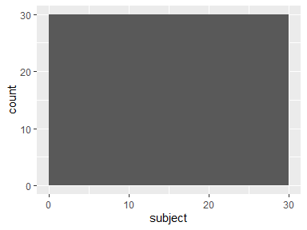

## activity

|  |  |
| --- | --- |
| Feature | Result |
| Variable type | factor |
| Number of missing obs. | 0 (0 %) |
| Number of unique values | 6 |
| Mode | “LAYING” |
| Reference category | LAYING |

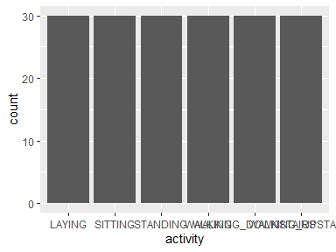

* Observed factor levels: "LAYING", "SITTING", "STANDING", "WALKING", "WALKING_DOWNSTAIRS", "WALKING_UPSTAIRS".

## Time BodyAcc mean x axis

|  |  |
| --- | --- |
| Feature | Result |
| Variable type | numeric |
| Number of missing obs. | 0 (0 %) |
| Number of unique values | 180 |
| Median | 0.28 |
| 1st and 3rd quartiles | 0.27; 0.28 |
| Min. and max. | 0.22; 0.3 |

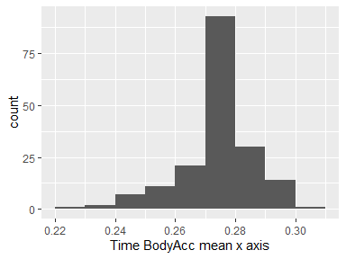

## Time BodyAcc mean y axis

|  |  |
| --- | --- |
| Feature | Result |
| Variable type | numeric |
| Number of missing obs. | 0 (0 %) |
| Number of unique values | 180 |
| Median | -0.02 |
| 1st and 3rd quartiles | -0.02; -0.01 |
| Min. and max. | -0.04; 0 |

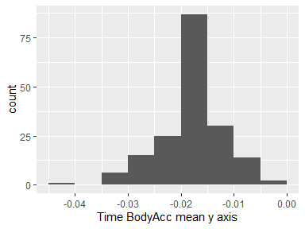

## Time BodyAcc mean z axis

|  |  |
| --- | --- |
| Feature | Result |
| Variable type | numeric |
| Number of missing obs. | 0 (0 %) |
| Number of unique values | 180 |
| Median | -0.11 |
| 1st and 3rd quartiles | -0.11; -0.1 |
| Min. and max. | -0.15; -0.08 |

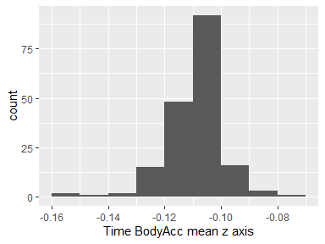

## Time BodyAcc std x axis

|  |  |
| --- | --- |
| Feature | Result |
| Variable type | numeric |
| Number of missing obs. | 0 (0 %) |
| Number of unique values | 180 |
| Median | -0.75 |
| 1st and 3rd quartiles | -0.98; -0.2 |
| Min. and max. | -1; 0.63 |

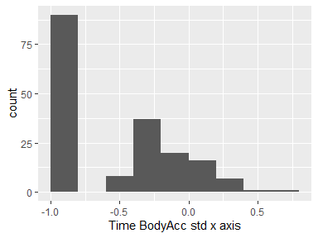

## Time BodyAcc std y axis

|  |  |
| --- | --- |
| Feature | Result |
| Variable type | numeric |
| Number of missing obs. | 0 (0 %) |
| Number of unique values | 180 |
| Median | -0.51 |
| 1st and 3rd quartiles | -0.94; -0.03 |
| Min. and max. | -0.99; 0.62 |

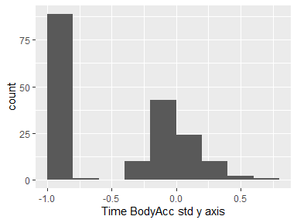

## Time BodyAcc std z axis

|  |  |
| --- | --- |
| Feature | Result |
| Variable type | numeric |
| Number of missing obs. | 0 (0 %) |
| Number of unique values | 180 |
| Median | -0.65 |
| 1st and 3rd quartiles | -0.95; -0.23 |
| Min. and max. | -0.99; 0.61 |

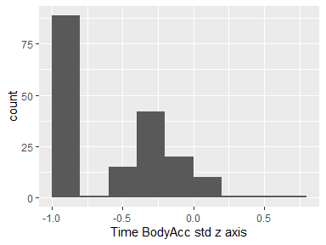

## Time GravityAcc mean x axis

|  |  |
| --- | --- |
| Feature | Result |
| Variable type | numeric |
| Number of missing obs. | 0 (0 %) |
| Number of unique values | 180 |
| Median | 0.92 |
| 1st and 3rd quartiles | 0.84; 0.94 |
| Min. and max. | -0.68; 0.97 |

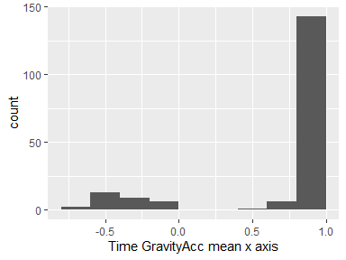

## Time GravityAcc mean y axis

|  |  |
| --- | --- |
| Feature | Result |
| Variable type | numeric |
| Number of missing obs. | 0 (0 %) |
| Number of unique values | 180 |
| Median | -0.13 |
| 1st and 3rd quartiles | -0.23; 0.09 |
| Min. and max. | -0.48; 0.96 |

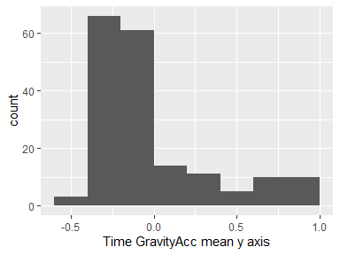

## Time GravityAcc mean z axis

|  |  |
| --- | --- |
| Feature | Result |
| Variable type | numeric |
| Number of missing obs. | 0 (0 %) |
| Number of unique values | 180 |
| Median | 0.02 |
| 1st and 3rd quartiles | -0.12; 0.15 |
| Min. and max. | -0.5; 0.96 |

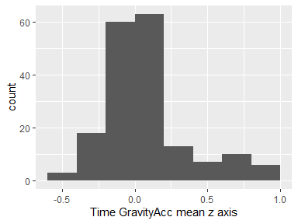

## Time GravityAcc std x axis

|  |  |
| --- | --- |
| Feature | Result |
| Variable type | numeric |
| Number of missing obs. | 0 (0 %) |
| Number of unique values | 180 |
| Median | -0.97 |
| 1st and 3rd quartiles | -0.98; -0.95 |
| Min. and max. | -1; -0.83 |

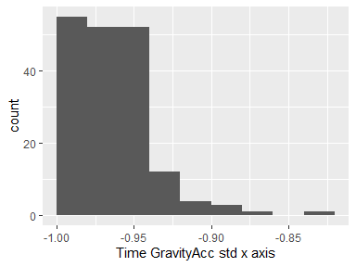

## Time GravityAcc std y axis

|  |  |
| --- | --- |
| Feature | Result |
| Variable type | numeric |
| Number of missing obs. | 0 (0 %) |
| Number of unique values | 180 |
| Median | -0.96 |
| 1st and 3rd quartiles | -0.97; -0.94 |
| Min. and max. | -0.99; -0.64 |

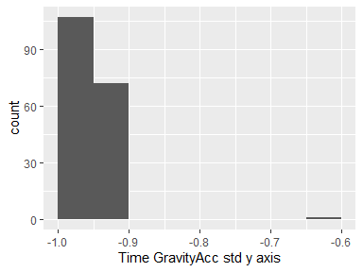

## Time GravityAcc std z axis

|  |  |
| --- | --- |
| Feature | Result |
| Variable type | numeric |
| Number of missing obs. | 0 (0 %) |
| Number of unique values | 180 |
| Median | -0.95 |
| 1st and 3rd quartiles | -0.96; -0.92 |
| Min. and max. | -0.99; -0.61 |

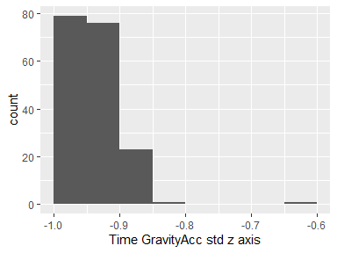

## Time BodyAccJerk mean x axis

|  |  |
| --- | --- |
| Feature | Result |
| Variable type | numeric |
| Number of missing obs. | 0 (0 %) |
| Number of unique values | 180 |
| Median | 0.08 |
| 1st and 3rd quartiles | 0.07; 0.08 |
| Min. and max. | 0.04; 0.13 |

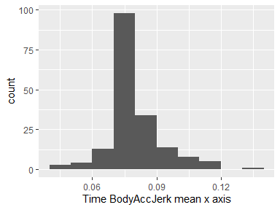

## Time BodyAccJerk mean y axis

|  |  |
| --- | --- |
| Feature | Result |
| Variable type | numeric |
| Number of missing obs. | 0 (0 %) |
| Number of unique values | 180 |
| Median | 0.01 |
| 1st and 3rd quartiles | 0; 0.01 |
| Min. and max. | -0.04; 0.06 |

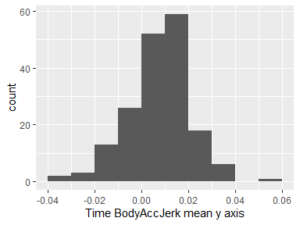

## Time BodyAccJerk mean z axis

|  |  |
| --- | --- |
| Feature | Result |
| Variable type | numeric |
| Number of missing obs. | 0 (0 %) |
| Number of unique values | 180 |
| Median | 0 |
| 1st and 3rd quartiles | -0.01; 0 |
| Min. and max. | -0.07; 0.04 |

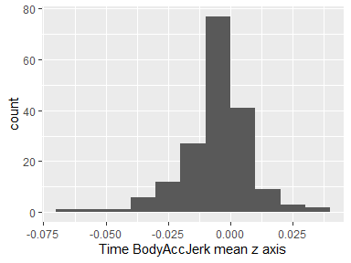

## Time BodyAccJerk std x axis

|  |  |
| --- | --- |
| Feature | Result |
| Variable type | numeric |
| Number of missing obs. | 0 (0 %) |
| Number of unique values | 180 |
| Median | -0.81 |
| 1st and 3rd quartiles | -0.98; -0.22 |
| Min. and max. | -0.99; 0.54 |

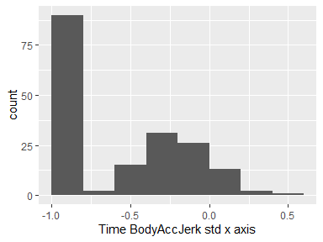

## Time BodyAccJerk std y axis

|  |  |
| --- | --- |
| Feature | Result |
| Variable type | numeric |
| Number of missing obs. | 0 (0 %) |
| Number of unique values | 180 |
| Median | -0.78 |
| 1st and 3rd quartiles | -0.97; -0.15 |
| Min. and max. | -0.99; 0.36 |

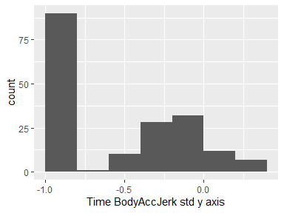

## Time BodyAccJerk std z axis

|  |  |
| --- | --- |
| Feature | Result |
| Variable type | numeric |
| Number of missing obs. | 0 (0 %) |
| Number of unique values | 180 |
| Median | -0.88 |
| 1st and 3rd quartiles | -0.98; -0.51 |
| Min. and max. | -0.99; 0.03 |

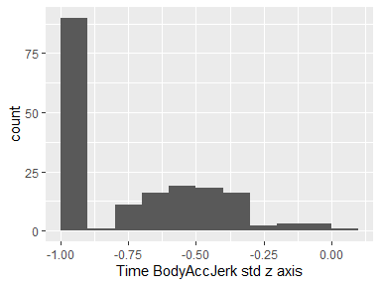

## Time BodyGyro mean x axis

|  |  |
| --- | --- |
| Feature | Result |
| Variable type | numeric |
| Number of missing obs. | 0 (0 %) |
| Number of unique values | 180 |
| Median | -0.03 |
| 1st and 3rd quartiles | -0.05; -0.02 |
| Min. and max. | -0.21; 0.19 |

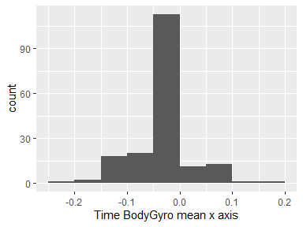

## Time BodyGyro mean y axis

|  |  |
| --- | --- |
| Feature | Result |
| Variable type | numeric |
| Number of missing obs. | 0 (0 %) |
| Number of unique values | 180 |
| Median | -0.07 |
| 1st and 3rd quartiles | -0.09; -0.06 |
| Min. and max. | -0.2; 0.03 |

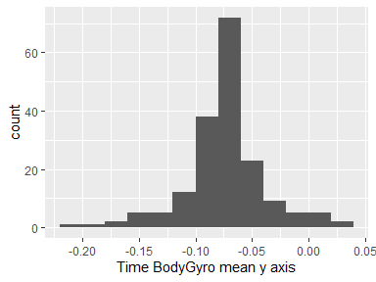

## Time BodyGyro mean z axis

|  |  |
| --- | --- |
| Feature | Result |
| Variable type | numeric |
| Number of missing obs. | 0 (0 %) |
| Number of unique values | 180 |
| Median | 0.09 |
| 1st and 3rd quartiles | 0.07; 0.1 |
| Min. and max. | -0.07; 0.18 |

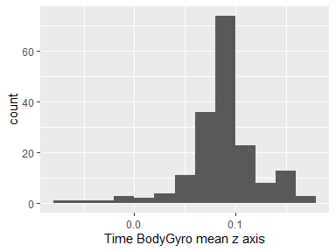

## Time BodyGyro std x axis

|  |  |
| --- | --- |
| Feature | Result |
| Variable type | numeric |
| Number of missing obs. | 0 (0 %) |
| Number of unique values | 180 |
| Median | -0.79 |
| 1st and 3rd quartiles | -0.97; -0.44 |
| Min. and max. | -0.99; 0.27 |

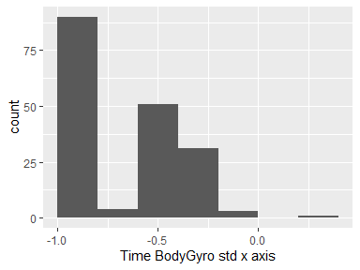

## Time BodyGyro std y axis

|  |  |
| --- | --- |
| Feature | Result |
| Variable type | numeric |
| Number of missing obs. | 0 (0 %) |
| Number of unique values | 180 |
| Median | -0.8 |
| 1st and 3rd quartiles | -0.96; -0.42 |
| Min. and max. | -0.99; 0.48 |

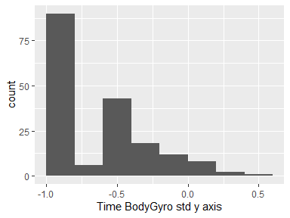

## Time BodyGyro std z axis

|  |  |
| --- | --- |
| Feature | Result |
| Variable type | numeric |
| Number of missing obs. | 0 (0 %) |
| Number of unique values | 180 |
| Median | -0.8 |
| 1st and 3rd quartiles | -0.96; -0.31 |
| Min. and max. | -0.99; 0.56 |

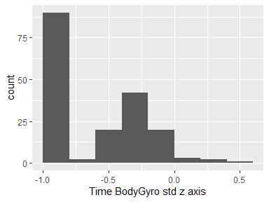

## Time BodyGyroJerk mean x axis

|  |  |
| --- | --- |
| Feature | Result |
| Variable type | numeric |
| Number of missing obs. | 0 (0 %) |
| Number of unique values | 180 |
| Median | -0.1 |
| 1st and 3rd quartiles | -0.1; -0.09 |
| Min. and max. | -0.16; -0.02 |

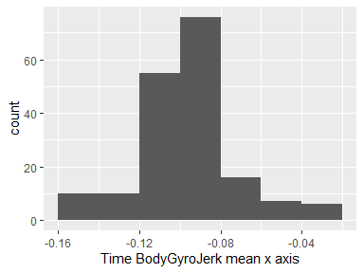

## Time BodyGyroJerk mean y axis

|  |  |
| --- | --- |
| Feature | Result |
| Variable type | numeric |
| Number of missing obs. | 0 (0 %) |
| Number of unique values | 180 |
| Median | -0.04 |
| 1st and 3rd quartiles | -0.05; -0.04 |
| Min. and max. | -0.08; -0.01 |

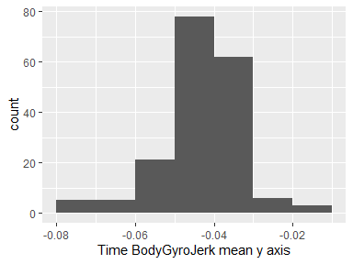

## Time BodyGyroJerk mean z axis

|  |  |
| --- | --- |
| Feature | Result |
| Variable type | numeric |
| Number of missing obs. | 0 (0 %) |
| Number of unique values | 180 |
| Median | -0.05 |
| 1st and 3rd quartiles | -0.06; -0.05 |
| Min. and max. | -0.09; -0.01 |

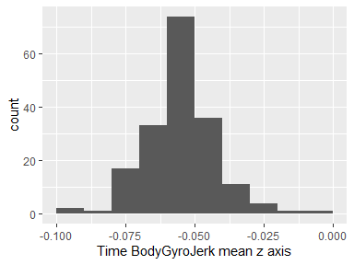

## Time BodyGyroJerk std x axis

|  |  |
| --- | --- |
| Feature | Result |
| Variable type | numeric |
| Number of missing obs. | 0 (0 %) |
| Number of unique values | 180 |
| Median | -0.84 |
| 1st and 3rd quartiles | -0.98; -0.46 |
| Min. and max. | -1; 0.18 |

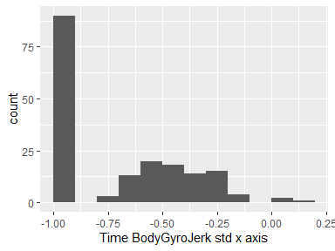

## Time BodyGyroJerk std y axis

|  |  |
| --- | --- |
| Feature | Result |
| Variable type | numeric |
| Number of missing obs. | 0 (0 %) |
| Number of unique values | 180 |
| Median | -0.89 |
| 1st and 3rd quartiles | -0.98; -0.59 |
| Min. and max. | -1; 0.3 |

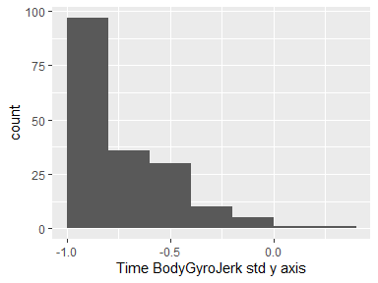

## Time BodyGyroJerk std z axis

|  |  |
| --- | --- |
| Feature | Result |
| Variable type | numeric |
| Number of missing obs. | 0 (0 %) |
| Number of unique values | 180 |
| Median | -0.86 |
| 1st and 3rd quartiles | -0.98; -0.47 |
| Min. and max. | -1; 0.19 |

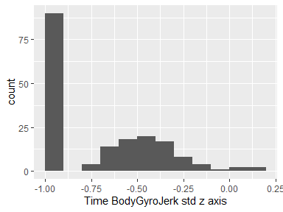

## Time BodyAccMag mean

|  |  |
| --- | --- |
| Feature | Result |
| Variable type | numeric |
| Number of missing obs. | 0 (0 %) |
| Number of unique values | 180 |
| Median | -0.48 |
| 1st and 3rd quartiles | -0.96; -0.09 |
| Min. and max. | -0.99; 0.64 |

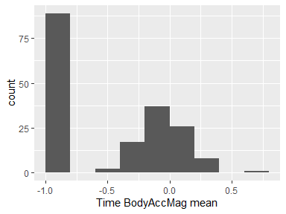

## Time BodyAccMag std

|  |  |
| --- | --- |
| Feature | Result |
| Variable type | numeric |
| Number of missing obs. | 0 (0 %) |
| Number of unique values | 180 |
| Median | -0.61 |
| 1st and 3rd quartiles | -0.94; -0.21 |
| Min. and max. | -0.99; 0.43 |

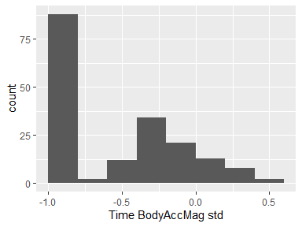

## Time GravityAccMag mean

|  |  |
| --- | --- |
| Feature | Result |
| Variable type | numeric |
| Number of missing obs. | 0 (0 %) |
| Number of unique values | 180 |
| Median | -0.48 |
| 1st and 3rd quartiles | -0.96; -0.09 |
| Min. and max. | -0.99; 0.64 |

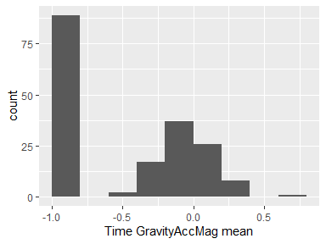

## Time GravityAccMag std

|  |  |
| --- | --- |
| Feature | Result |
| Variable type | numeric |
| Number of missing obs. | 0 (0 %) |
| Number of unique values | 180 |
| Median | -0.61 |
| 1st and 3rd quartiles | -0.94; -0.21 |
| Min. and max. | -0.99; 0.43 |

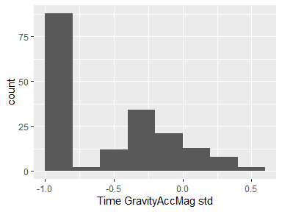

## Time BodyAccJerkMag mean

|  |  |
| --- | --- |
| Feature | Result |
| Variable type | numeric |
| Number of missing obs. | 0 (0 %) |
| Number of unique values | 180 |
| Median | -0.82 |
| 1st and 3rd quartiles | -0.98; -0.25 |
| Min. and max. | -0.99; 0.43 |

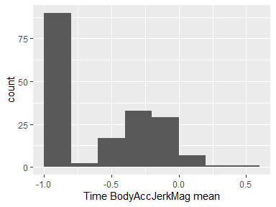

## Time BodyAccJerkMag std

|  |  |
| --- | --- |
| Feature | Result |
| Variable type | numeric |
| Number of missing obs. | 0 (0 %) |
| Number of unique values | 180 |
| Median | -0.8 |
| 1st and 3rd quartiles | -0.98; -0.22 |
| Min. and max. | -0.99; 0.45 |

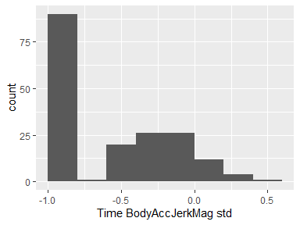

## Time BodyGyroMag mean

|  |  |
| --- | --- |
| Feature | Result |
| Variable type | numeric |
| Number of missing obs. | 0 (0 %) |
| Number of unique values | 180 |
| Median | -0.66 |
| 1st and 3rd quartiles | -0.95; -0.22 |
| Min. and max. | -0.98; 0.42 |

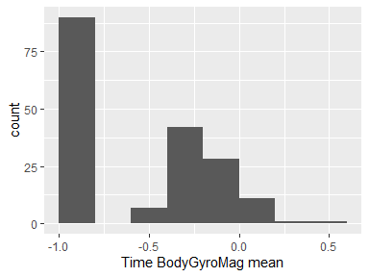

## Time BodyGyroMag std

|  |  |
| --- | --- |
| Feature | Result |
| Variable type | numeric |
| Number of missing obs. | 0 (0 %) |
| Number of unique values | 180 |
| Median | -0.74 |
| 1st and 3rd quartiles | -0.95; -0.36 |
| Min. and max. | -0.98; 0.3 |

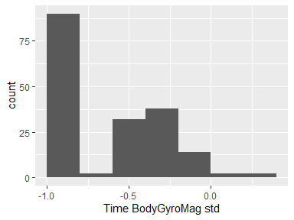

## Time BodyGyroJerkMag mean

|  |  |
| --- | --- |
| Feature | Result |
| Variable type | numeric |
| Number of missing obs. | 0 (0 %) |
| Number of unique values | 180 |
| Median | -0.86 |
| 1st and 3rd quartiles | -0.99; -0.51 |
| Min. and max. | -1; 0.09 |

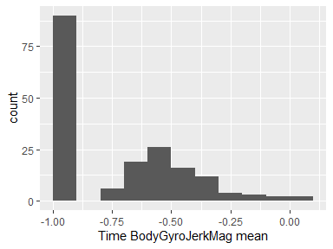

## Time BodyGyroJerkMag std

|  |  |
| --- | --- |
| Feature | Result |
| Variable type | numeric |
| Number of missing obs. | 0 (0 %) |
| Number of unique values | 180 |
| Median | -0.88 |
| 1st and 3rd quartiles | -0.98; -0.58 |
| Min. and max. | -1; 0.25 |

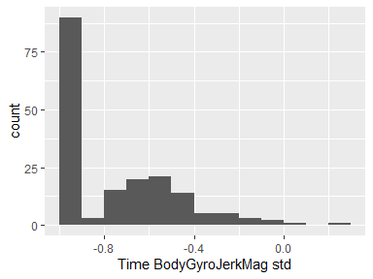

## Frequency BodyAcc mean x axis

|  |  |
| --- | --- |
| Feature | Result |
| Variable type | numeric |
| Number of missing obs. | 0 (0 %) |
| Number of unique values | 180 |
| Median | -0.77 |
| 1st and 3rd quartiles | -0.98; -0.22 |
| Min. and max. | -1; 0.54 |

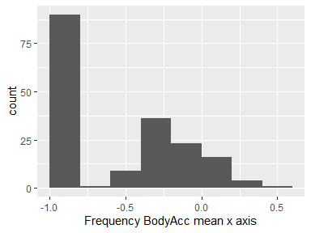

## Frequency BodyAcc mean y axis

|  |  |
| --- | --- |
| Feature | Result |
| Variable type | numeric |
| Number of missing obs. | 0 (0 %) |
| Number of unique values | 180 |
| Median | -0.59 |
| 1st and 3rd quartiles | -0.95; -0.06 |
| Min. and max. | -0.99; 0.52 |

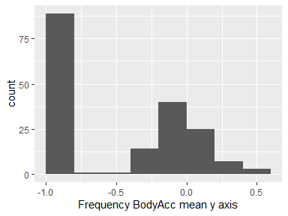

## Frequency BodyAcc mean z axis

|  |  |
| --- | --- |
| Feature | Result |
| Variable type | numeric |
| Number of missing obs. | 0 (0 %) |
| Number of unique values | 180 |
| Median | -0.72 |
| 1st and 3rd quartiles | -0.96; -0.32 |
| Min. and max. | -0.99; 0.28 |

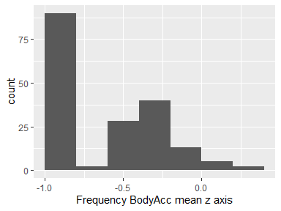

## Frequency BodyAcc std x axis

|  |  |
| --- | --- |
| Feature | Result |
| Variable type | numeric |
| Number of missing obs. | 0 (0 %) |
| Number of unique values | 180 |
| Median | -0.75 |
| 1st and 3rd quartiles | -0.98; -0.2 |
| Min. and max. | -1; 0.66 |

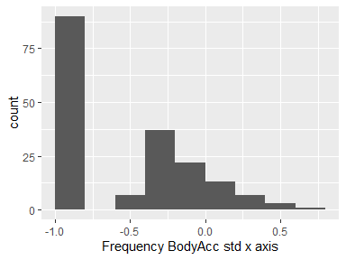

## Frequency BodyAcc std y axis

|  |  |
| --- | --- |
| Feature | Result |
| Variable type | numeric |
| Number of missing obs. | 0 (0 %) |
| Number of unique values | 180 |
| Median | -0.51 |
| 1st and 3rd quartiles | -0.94; -0.08 |
| Min. and max. | -0.99; 0.56 |

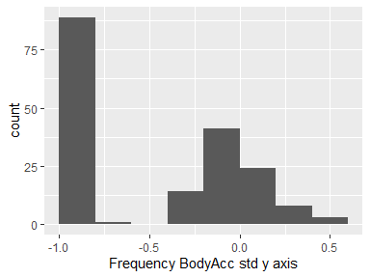

## Frequency BodyAcc std z axis

|  |  |
| --- | --- |
| Feature | Result |
| Variable type | numeric |
| Number of missing obs. | 0 (0 %) |
| Number of unique values | 180 |
| Median | -0.64 |
| 1st and 3rd quartiles | -0.95; -0.27 |
| Min. and max. | -0.99; 0.69 |

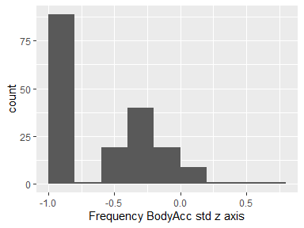

## Frequency BodyAcc meanFreq x axis

|  |  |
| --- | --- |
| Feature | Result |
| Variable type | numeric |
| Number of missing obs. | 0 (0 %) |
| Number of unique values | 180 |
| Median | -0.26 |
| 1st and 3rd quartiles | -0.39; -0.06 |
| Min. and max. | -0.64; 0.16 |

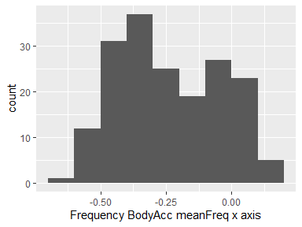

## Frequency BodyAcc meanFreq y axis

|  |  |
| --- | --- |
| Feature | Result |
| Variable type | numeric |
| Number of missing obs. | 0 (0 %) |
| Number of unique values | 180 |
| Median | 0.01 |
| 1st and 3rd quartiles | -0.08; 0.09 |
| Min. and max. | -0.38; 0.47 |

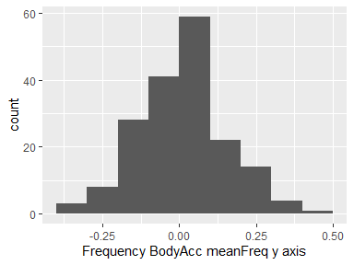

## Frequency BodyAcc meanFreq z axis

|  |  |
| --- | --- |
| Feature | Result |
| Variable type | numeric |
| Number of missing obs. | 0 (0 %) |
| Number of unique values | 180 |
| Median | 0.07 |
| 1st and 3rd quartiles | -0.04; 0.18 |
| Min. and max. | -0.52; 0.4 |

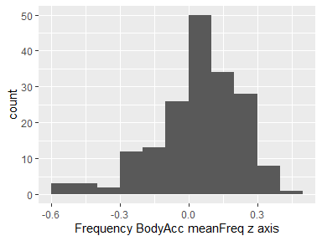

## Frequency BodyAccJerk mean x axis

|  |  |
| --- | --- |
| Feature | Result |
| Variable type | numeric |
| Number of missing obs. | 0 (0 %) |
| Number of unique values | 180 |
| Median | -0.81 |
| 1st and 3rd quartiles | -0.98; -0.28 |
| Min. and max. | -0.99; 0.47 |

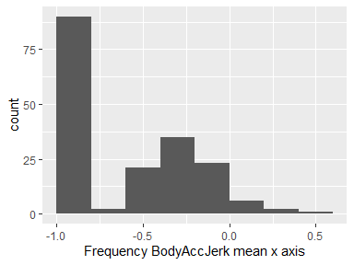

## Frequency BodyAccJerk mean y axis

|  |  |
| --- | --- |
| Feature | Result |
| Variable type | numeric |
| Number of missing obs. | 0 (0 %) |
| Number of unique values | 180 |
| Median | -0.78 |
| 1st and 3rd quartiles | -0.97; -0.2 |
| Min. and max. | -0.99; 0.28 |

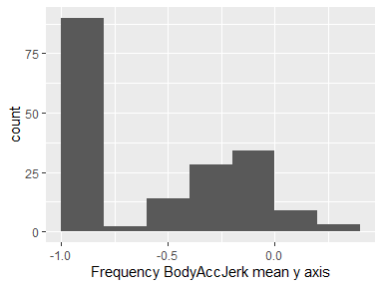

## Frequency BodyAccJerk mean z axis

|  |  |
| --- | --- |
| Feature | Result |
| Variable type | numeric |
| Number of missing obs. | 0 (0 %) |
| Number of unique values | 180 |
| Median | -0.87 |
| 1st and 3rd quartiles | -0.98; -0.47 |
| Min. and max. | -0.99; 0.16 |

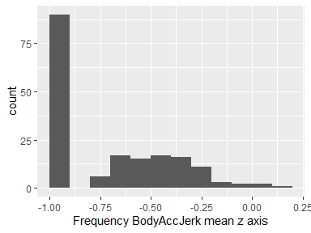

## Frequency BodyAccJerk std x axis

|  |  |
| --- | --- |
| Feature | Result |
| Variable type | numeric |
| Number of missing obs. | 0 (0 %) |
| Number of unique values | 180 |
| Median | -0.83 |
| 1st and 3rd quartiles | -0.98; -0.25 |
| Min. and max. | -1; 0.48 |

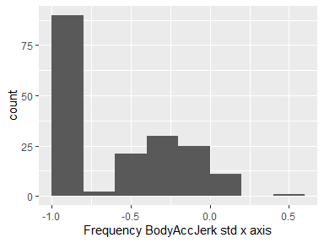

## Frequency BodyAccJerk std y axis

|  |  |
| --- | --- |
| Feature | Result |
| Variable type | numeric |
| Number of missing obs. | 0 (0 %) |
| Number of unique values | 180 |
| Median | -0.79 |
| 1st and 3rd quartiles | -0.97; -0.17 |
| Min. and max. | -0.99; 0.35 |

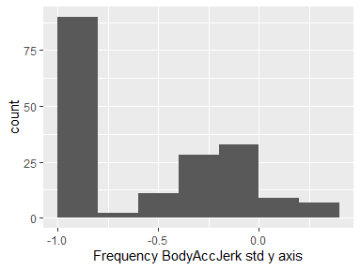

## Frequency BodyAccJerk std z axis

|  |  |
| --- | --- |
| Feature | Result |
| Variable type | numeric |
| Number of missing obs. | 0 (0 %) |
| Number of unique values | 180 |
| Median | -0.9 |
| 1st and 3rd quartiles | -0.98; -0.54 |
| Min. and max. | -0.99; -0.01 |

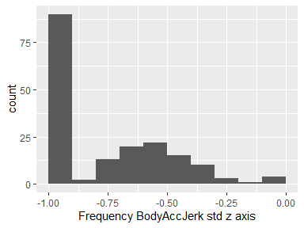

## Frequency BodyAccJerk meanFreq x axis

|  |  |
| --- | --- |
| Feature | Result |
| Variable type | numeric |
| Number of missing obs. | 0 (0 %) |
| Number of unique values | 180 |
| Median | -0.06 |
| 1st and 3rd quartiles | -0.29; 0.18 |
| Min. and max. | -0.58; 0.33 |

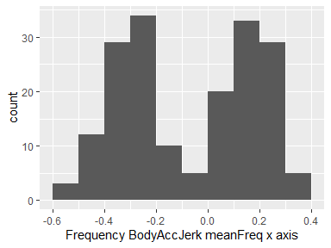

## Frequency BodyAccJerk meanFreq y axis

|  |  |
| --- | --- |
| Feature | Result |
| Variable type | numeric |
| Number of missing obs. | 0 (0 %) |
| Number of unique values | 180 |
| Median | -0.23 |
| 1st and 3rd quartiles | -0.4; -0.05 |
| Min. and max. | -0.6; 0.2 |

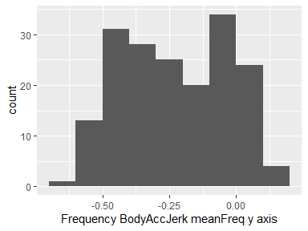

## Frequency BodyAccJerk meanFreq z axis

|  |  |
| --- | --- |
| Feature | Result |
| Variable type | numeric |
| Number of missing obs. | 0 (0 %) |
| Number of unique values | 180 |
| Median | -0.09 |
| 1st and 3rd quartiles | -0.31; 0.04 |
| Min. and max. | -0.63; 0.23 |

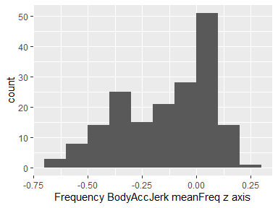

## Frequency BodyGyro mean x axis

|  |  |
| --- | --- |
| Feature | Result |
| Variable type | numeric |
| Number of missing obs. | 0 (0 %) |
| Number of unique values | 180 |
| Median | -0.73 |
| 1st and 3rd quartiles | -0.97; -0.34 |
| Min. and max. | -0.99; 0.47 |

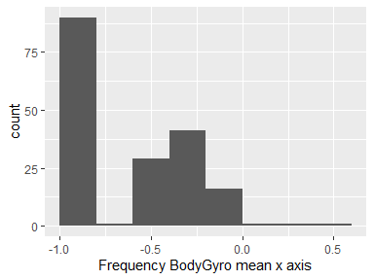

## Frequency BodyGyro mean y axis

|  |  |
| --- | --- |
| Feature | Result |
| Variable type | numeric |
| Number of missing obs. | 0 (0 %) |
| Number of unique values | 180 |
| Median | -0.81 |
| 1st and 3rd quartiles | -0.97; -0.45 |
| Min. and max. | -0.99; 0.33 |

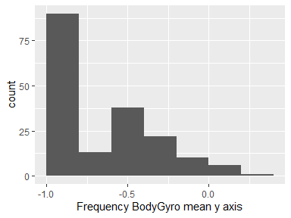

## Frequency BodyGyro mean z axis

|  |  |
| --- | --- |
| Feature | Result |
| Variable type | numeric |
| Number of missing obs. | 0 (0 %) |
| Number of unique values | 180 |
| Median | -0.79 |
| 1st and 3rd quartiles | -0.96; -0.26 |
| Min. and max. | -0.99; 0.49 |

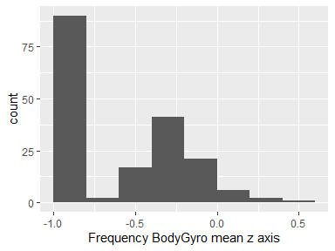

## Frequency BodyGyro std x axis

|  |  |
| --- | --- |
| Feature | Result |
| Variable type | numeric |
| Number of missing obs. | 0 (0 %) |
| Number of unique values | 180 |
| Median | -0.81 |
| 1st and 3rd quartiles | -0.98; -0.48 |
| Min. and max. | -0.99; 0.2 |

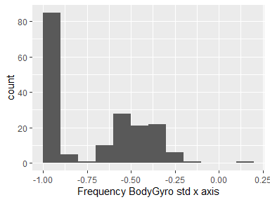

## Frequency BodyGyro std y axis

|  |  |
| --- | --- |
| Feature | Result |
| Variable type | numeric |
| Number of missing obs. | 0 (0 %) |
| Number of unique values | 180 |
| Median | -0.8 |
| 1st and 3rd quartiles | -0.96; -0.42 |
| Min. and max. | -0.99; 0.65 |

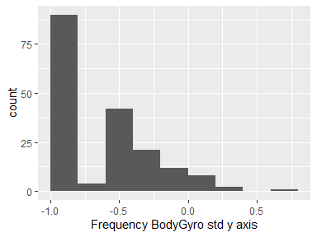

## Frequency BodyGyro std z axis

|  |  |
| --- | --- |
| Feature | Result |
| Variable type | numeric |
| Number of missing obs. | 0 (0 %) |
| Number of unique values | 180 |
| Median | -0.82 |
| 1st and 3rd quartiles | -0.96; -0.39 |
| Min. and max. | -0.99; 0.52 |

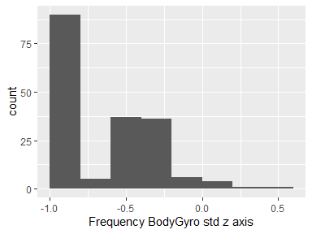

## Frequency BodyGyro meanFreq x axis

|  |  |
| --- | --- |
| Feature | Result |
| Variable type | numeric |
| Number of missing obs. | 0 (0 %) |
| Number of unique values | 180 |
| Median | -0.12 |
| 1st and 3rd quartiles | -0.21; 0 |
| Min. and max. | -0.4; 0.25 |

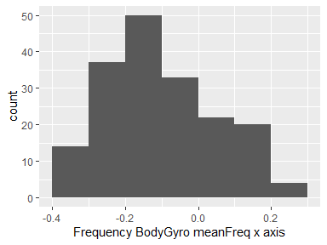

## Frequency BodyGyro meanFreq y axis

|  |  |
| --- | --- |
| Feature | Result |
| Variable type | numeric |
| Number of missing obs. | 0 (0 %) |
| Number of unique values | 180 |
| Median | -0.16 |
| 1st and 3rd quartiles | -0.29; -0.04 |
| Min. and max. | -0.67; 0.27 |

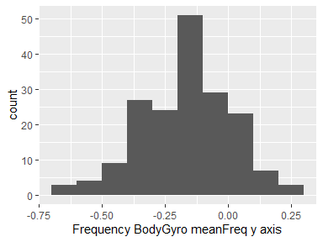

## Frequency BodyGyro meanFreq z axis

|  |  |
| --- | --- |
| Feature | Result |
| Variable type | numeric |
| Number of missing obs. | 0 (0 %) |
| Number of unique values | 180 |
| Median | -0.05 |
| 1st and 3rd quartiles | -0.15; 0.04 |
| Min. and max. | -0.51; 0.38 |

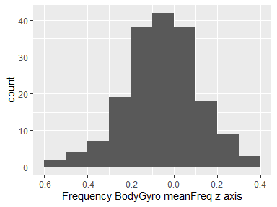

## Frequency BodyAccMag mean

|  |  |
| --- | --- |
| Feature | Result |
| Variable type | numeric |
| Number of missing obs. | 0 (0 %) |
| Number of unique values | 180 |
| Median | -0.67 |
| 1st and 3rd quartiles | -0.96; -0.16 |
| Min. and max. | -0.99; 0.59 |

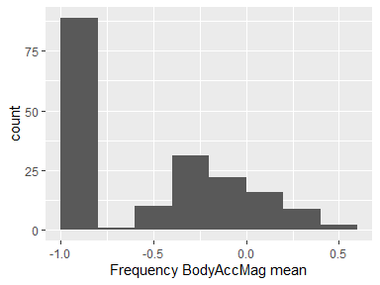

## Frequency BodyAccMag std

|  |  |
| --- | --- |
| Feature | Result |
| Variable type | numeric |
| Number of missing obs. | 0 (0 %) |
| Number of unique values | 180 |
| Median | -0.65 |
| 1st and 3rd quartiles | -0.95; -0.37 |
| Min. and max. | -0.99; 0.18 |

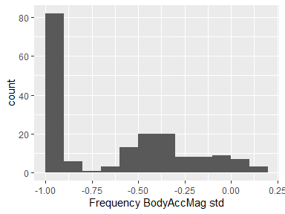

## Frequency BodyAccMag meanFreq

|  |  |
| --- | --- |
| Feature | Result |
| Variable type | numeric |
| Number of missing obs. | 0 (0 %) |
| Number of unique values | 180 |
| Median | 0.08 |
| 1st and 3rd quartiles | -0.01; 0.17 |
| Min. and max. | -0.31; 0.44 |

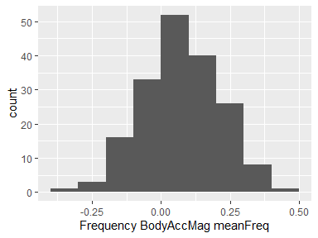

## Frequency BodyBodyAccJerkMag mean

|  |  |
| --- | --- |
| Feature | Result |
| Variable type | numeric |
| Number of missing obs. | 0 (0 %) |
| Number of unique values | 180 |
| Median | -0.79 |
| 1st and 3rd quartiles | -0.98; -0.19 |
| Min. and max. | -0.99; 0.54 |

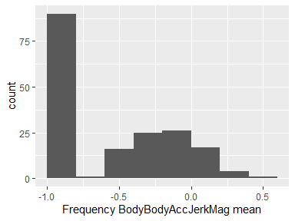

## Frequency BodyBodyAccJerkMag std

|  |  |
| --- | --- |
| Feature | Result |
| Variable type | numeric |
| Number of missing obs. | 0 (0 %) |
| Number of unique values | 180 |
| Median | -0.81 |
| 1st and 3rd quartiles | -0.98; -0.27 |
| Min. and max. | -0.99; 0.32 |

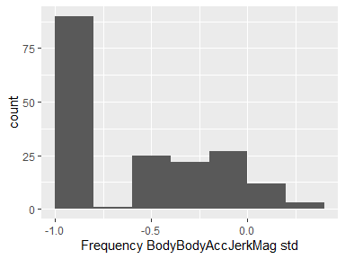

## Frequency BodyBodyAccJerkMag meanFreq

|  |  |
| --- | --- |
| Feature | Result |
| Variable type | numeric |
| Number of missing obs. | 0 (0 %) |
| Number of unique values | 180 |
| Median | 0.17 |
| 1st and 3rd quartiles | 0.05; 0.28 |
| Min. and max. | -0.13; 0.49 |

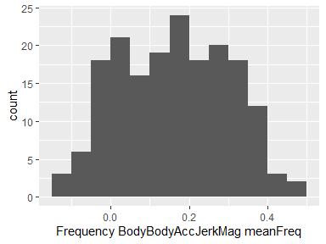

## Frequency BodyBodyGyroMag mean

|  |  |
| --- | --- |
| Feature | Result |
| Variable type | numeric |
| Number of missing obs. | 0 (0 %) |
| Number of unique values | 180 |
| Median | -0.77 |
| 1st and 3rd quartiles | -0.96; -0.41 |
| Min. and max. | -0.99; 0.2 |

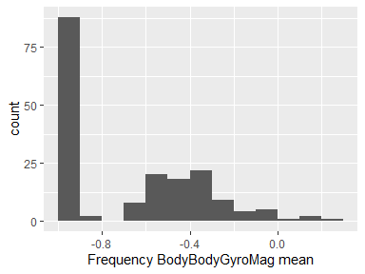

## Frequency BodyBodyGyroMag std

|  |  |
| --- | --- |
| Feature | Result |
| Variable type | numeric |
| Number of missing obs. | 0 (0 %) |
| Number of unique values | 180 |
| Median | -0.77 |
| 1st and 3rd quartiles | -0.95; -0.43 |
| Min. and max. | -0.98; 0.24 |

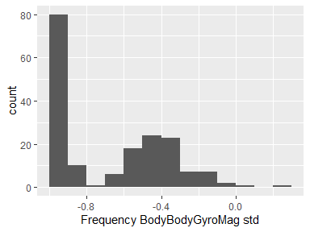

## Frequency BodyBodyGyroMag meanFreq

|  |  |
| --- | --- |
| Feature | Result |
| Variable type | numeric |
| Number of missing obs. | 0 (0 %) |
| Number of unique values | 180 |
| Median | -0.05 |
| 1st and 3rd quartiles | -0.17; 0.08 |
| Min. and max. | -0.46; 0.41 |

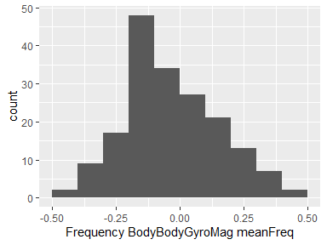

## Frequency BodyBodyGyroJerkMag mean

|  |  |
| --- | --- |
| Feature | Result |
| Variable type | numeric |
| Number of missing obs. | 0 (0 %) |
| Number of unique values | 180 |
| Median | -0.88 |
| 1st and 3rd quartiles | -0.98; -0.58 |
| Min. and max. | -1; 0.15 |

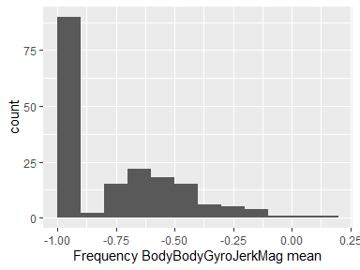

## Frequency BodyBodyGyroJerkMag std

|  |  |
| --- | --- |
| Feature | Result |
| Variable type | numeric |
| Number of missing obs. | 0 (0 %) |
| Number of unique values | 180 |
| Median | -0.89 |
| 1st and 3rd quartiles | -0.98; -0.61 |
| Min. and max. | -1; 0.29 |

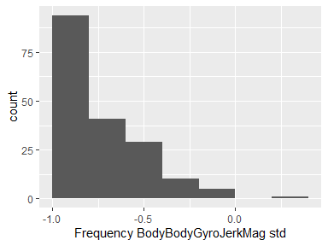

## Frequency BodyBodyGyroJerkMag meanFreq

|  |  |
| --- | --- |
| Feature | Result |
| Variable type | numeric |
| Number of missing obs. | 0 (0 %) |
| Number of unique values | 180 |
| Median | 0.11 |
| 1st and 3rd quartiles | 0.05; 0.21 |
| Min. and max. | -0.18; 0.43 |

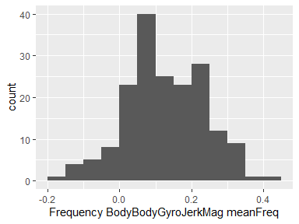

Report generation information:

* Created by akshayamrit (username: aksha).
* Report creation time: Fri Jul 26 2019 09:59:02
* Report was run from directory: C:/Users/aksha/Documents/datasciencecoursera/Getting and Cleaning Data/Course Project
* dataMaid v1.3.1 [Pkg: 2019-07-10 from CRAN (R 3.6.1)]
* R version 3.6.0 (2019-04-26).
* Platform: x86_64-w64-mingw32/x64 (64-bit)(Windows 10 x64 (build 18362)).
* Function call: makeDataReport(data = tidy_data, mode = c("summarize", "visualize", "check"), smartNum = FALSE, file = "codebook_tidy_data2.Rmd", vol = 2, checks = list(character = "showAllFactorLevels", factor = "showAllFactorLevels", labelled = "showAllFactorLevels", haven_labelled = "showAllFactorLevels", numeric = NULL, integer = NULL, logical = NULL, Date = NULL), listChecks = FALSE, maxProbVals = Inf, codebook = TRUE, reportTitle = "tidy_data codebook")